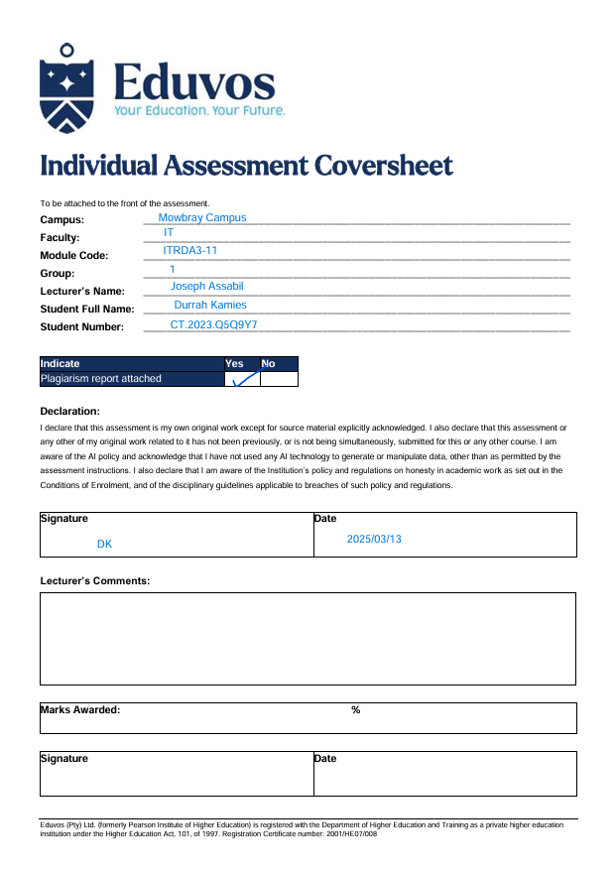
Github links:
https://github.com/Durrah-Kamies/Eduvos-IT-Dashboard/blob/2c3aea318138a57183b76da14d5bceca7a865209/q3.R
https://github.com/Durrah-Kamies/Eduvos-IT-Dashboard.git

ITRDA QUESTION 4:
Eduvos IT Graduate Survey Analysis Report
1. Introduction
This report analyses survey data collected from Eduvos IT graduates. The primary objective is to identify the databases, online frameworks, cloud platforms, programming languages, and artificial intelligence technologies that recent graduates use the most. By researching these topics, Eduvos can better align its curriculum with industry trends and provide students with the skills that employers value.
These are some of the main areas of focus:
- The languages used by recent grads for programming.
- Databases that are commonly used by fresh graduates.
- Web frameworks for positions in development.
- Graduates use AI tools and cloud platforms.

2. Data Overview
Details on Eduvos IT alumni, including their campus, employment type, field of study, and the technologies they utilize for work or personal projects, are included in the dataset used in this study.
Crucial elements:
Study Field: The field of study, like IT or data science.
Campus: The campus site, such as Mowbray or Port Elizabeth.
Work: The kind of employment (part-time, full-time, etc.).
Coding Activities: Open-source, professional, and hobby projects are among the types of coding projects that graduates work on.
Professional Tech: Technologies like databases, computer languages, and web frameworks used by recent grads.

3. Data Preparation
To ensure accuracy, the following methods were used to clean the data:
-Splitting and maintaining many values in columns such as professional Tech and Coding Activities.
-To maintain the integrity of the analysis, entries containing incomplete or missing data for significant variables like Study Field and Employment should be removed.

4. Insights and Analysis
1. Programming language usage:
Python is the most popular programming language among recent graduates, per the poll results. It is particularly popular for use in general-purpose programming and data science applications. Java and JavaScript are other popular languages that are commonly used in front-end and back-end programming, respectively.
2. Databases: MySQL and PostgreSQL are the most widely used SQL databases among Eduvos graduates. Additionally, MongoDB, a NoSQL database, is growing in popularity, especially among recent graduates working for cloud computing firms or digital startups.
3. Web Frameworks: The two most widely used web frameworks are React (for JavaScript) and Django (for Python). Python's popularity is reflected in the use of Django, while React is favoured for frontend development due to its versatility and widespread application in the IT industry.
4. Cloud Platforms: The two cloud platforms that recent graduates use the most are Microsoft Azure and Amazon Web Services (AWS). As companies move to cloud-based infrastructure, these platforms are growing in importance, highlighting the need for cloud computing skills in the workforce.
5. Artificial Intelligence Tools: TensorFlow and PyTorch are two examples of the AI tools that graduates working in data science and AI are increasingly using. These technologies are essential for developing machine learning models and demonstrate the growing demand for AI knowledge.
4. Recommendations
1. Curriculum Development: To better prepare graduates for the job market, Eduvos should consider changing its curriculum in the following ways:
-There should be more or more courses on Python and its applications in machine learning and data science.
-Since new graduates often use AWS and Azure, offer specialized training in cloud computing with a focus on these platforms.
-To familiarize students with a variety of data management tools, such as real-world projects utilizing both SQL and NoSQL databases.
2. Focus Areas:
AI Tools: Given the growing popularity of TensorFlow and PyTorch, machine learning and AI courses that offer practical experience with these tools ought to be included in the curriculum.
Web development: More classes covering full-stack programming, including front-end and back-end frameworks like React and Django, should be offered. This will make it easier for graduates to go into a variety of development roles.
3. Industry Alignment:
To keep the curriculum in line with current market trends, Eduvos should:
-By working with IT companies, provide workshops or internships on topics like artificial intelligence and cloud computing.
-Ensure that the curriculum is revised frequently to reflect the evolving needs of the technology industry, particularly in areas like artificial intelligence, cloud computing, and web development.

Python, SQL databases, and cloud computing platforms like AWS are among the technologies that graduates most commonly use, according to the Eduvos IT graduates' survey study. Eduvos can better educate its students for success in the modern job market by incorporating cutting-edge resources like cloud computing and artificial intelligence into the curriculum and adjusting it to new advances. Along with improving the employability of graduates, these enhancements will enhance the institution's standing as a provider of industry-relevant education.
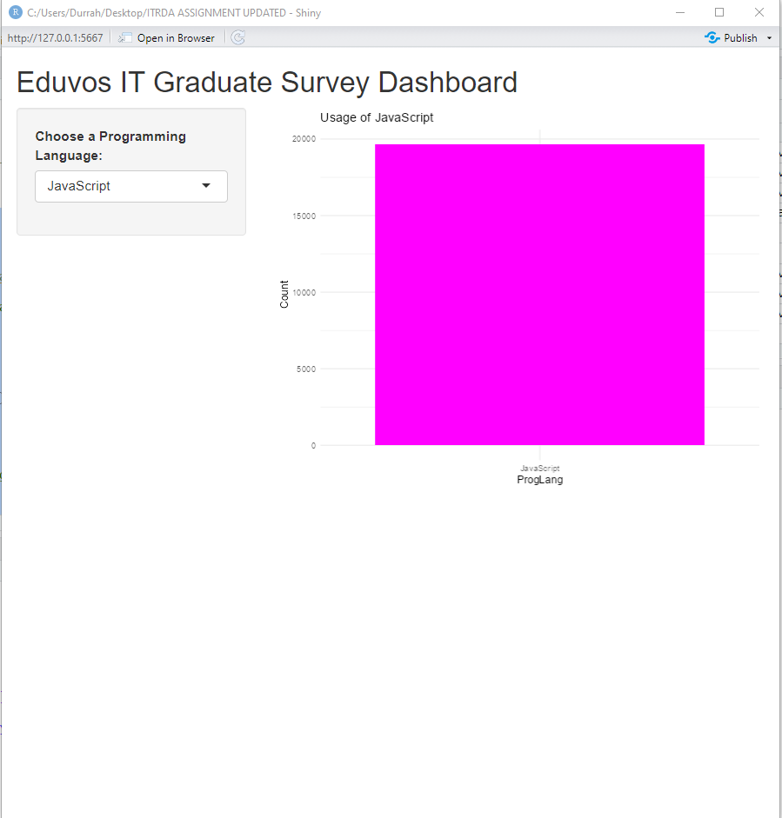
Visuals:
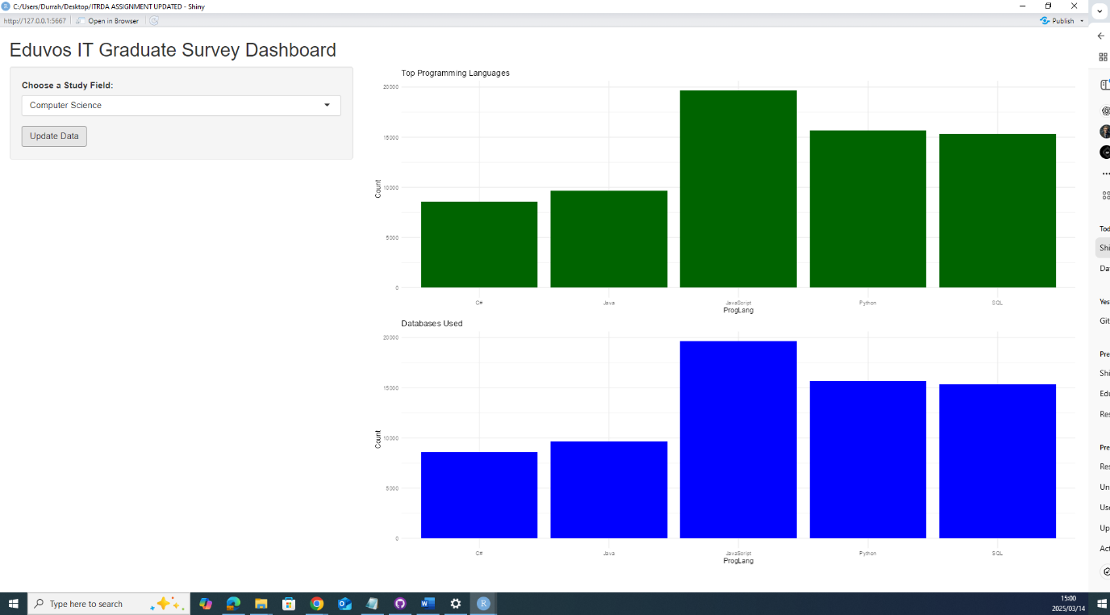

Bibliography
Applison, 2020. Tutorial: Create and Customize a Simple R Shiny Dashboard. [Online]
Available at: https://www.youtube.com/watch?v=41jmGq7ALMY
[Accessed 4 March 2025].
Chester Ismay and Albert Y. Kim, F. b. K. S. M., 2025. ModernDive. [Online]
Available at: https://moderndive.com/index.html
[Accessed 25 February 2025].
geeksforgeeks, 2024. Getting started with Data Visualization in R. [Online]
Available at: https://www.geeksforgeeks.org/data-visualization-in-r/
[Accessed 26 February 2025].
github, n.d. Cloning a repository. [Online]
Available at: https://docs.github.com/en/repositories/creating-and-managing-repositories/cloning-a-repository
[Accessed 8 March 2025].
Master, V. T., 2022. How to upload files/folders/projects on github | Upload Project folder on github (Simple Way). [Online]
Available at: https://www.youtube.com/watch?v=eGaImwD8fPQ
[Accessed 6 March 2025].
stackoverflow, 2022. How to save a subset of a dataset as .csv file?. [Online]
Available at: https://stackoverflow.com/questions/70550252/how-to-save-a-subset-of-a-dataset-as-csv-file
[Accessed 2 March 2025].

